|  |
| --- |
| **Change Master App** |
| **Version History**   |  |  |  |  | | --- | --- | --- | --- | | Date | Version | Author | Changes | | 16/03/2021 | 1 | L Boonekamp | Initial | |  |  |  |  | |

Contents

How to access the Change Master App 3

How to create a Change 3

Submitting your Change 3

Adding a Part to your Green 3

Removing a Part from your Green 4

Editing a Change 4

Completing a Change 4

Cancelling a Change 4

Viewing a Change 5

Searching and filtering Change Requests 4

Quick Filters 5

Date Range 5

Job Number or GreenID 5

Created by Department or Deliver To Department 5

My results aren’t being returned 5

Issues/Requests 4

# How to access the Change Master App

The Sheet Metal Greens App provides a way for Line staff to raise Greens for missing or damaged Sheet Metal.

Open <https://apps.temperzone.com/SheetMetalGreens> in Microsoft Edge or Google Chrome.

To access you will be asked to authenticate using your email address and password. This will mean that you will get a phone call or message from your Authenticator app and will need to take the appropriate action.

# How to create a Change

Once signed on, click on the ‘New’ tab. The New tab is displayed below.

## Submitting your Change

All fields are mandatory besides ‘Notes’.

### Adding a Part to your Green

Adding a part is easy and is done under the Parts to Remake section of the form. This section is shown below.

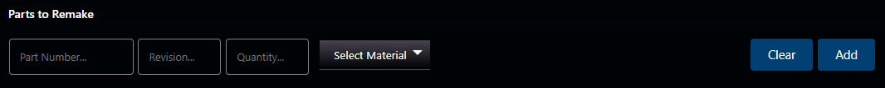

All fields are required in this section.

Select a Material. Once a Material is selected, the Thickness field appears.



Select a Thickness. The Finish field finally appears.



Select a Finish and you’re now ready to click the ‘Add’ button to add the part to your Green.

If you’ve made a mistake, you can clear your inputs using the ‘Clear’ button.



When you’re ready to submit your Green. Click the ‘Submit’ button.



You’ve successfully created your Green and it now has the Status of Awaiting Programmer. The Programmers will be notified and your Green will be picked up, processed and completed.

### Removing a Part from your Green

Removing a part from your Green can only be done before you’ve submitted it. Once you’ve submitted your Green it can no longer be removed.

To remove a part that has already been added, clicked the ‘X’ button on the right side of the line item as shown below.



# Editing a Change

Completing a Green is now done by the person who raised it. This new methodology ensures that the lines acknowledge receipt of their Green.

Only the staff member or Line that raised the Green, can complete the Green.

To complete a Green, search for the Job Number or GreenID by clicking the ‘List’ tab at the top of the screen.

**Note**: Only the person or line in the ‘Created By’ or ‘Deliver to Department’ fields will see the ‘Complete’ button at the bottom of the screen.

# Completing a Change

To close out of the current window, use the bright green tab at the top. It will look similar to the button below.



Or use the ‘Close’ button at the bottom of the window.



**Note**: The List and New buttons will be disabled until you close the current window.



# Cancelling a Change

Programmers will receive a notification when a Green is created.

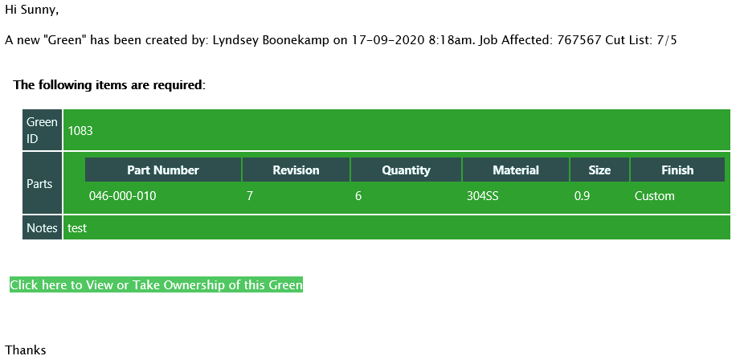

There are four statuses used during the lifecycle of a Green;

1. Awaiting Programmer – Initial status when the Lines first create the Green.
2. Programming – After a Programmer has taken ownership of the Green.
3. Being Manufactured – After a Programmer has finished programming the Green, it’s now being manufactured.
4. Completed – The initiator (Lines) upon receipt of their remade part, will go into the app and acknowledge completion, setting the status of the Green to Completed.

## Viewing a Green

To view a Green, click the link at the bottom of the notification ‘Click here to View or Take Ownership of this Green’. The Green is displayed.

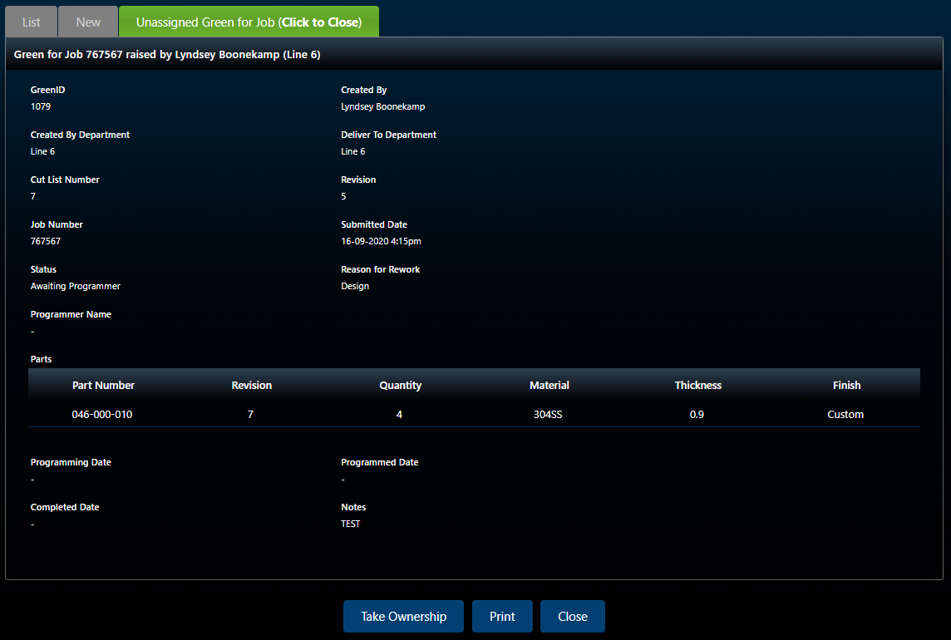

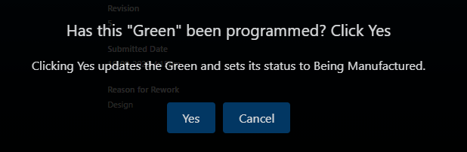

Click ‘Yes’ to proceed. The Green is updated and the Status is now Being Manufactured.

Click ‘Cancel’ to close the dialog.

# Searching and filtering Change Requests

Searching and filtering allows you to find Greens based on a criteria.

To perform a search click the ‘List’ tab.



The following window is displayed.

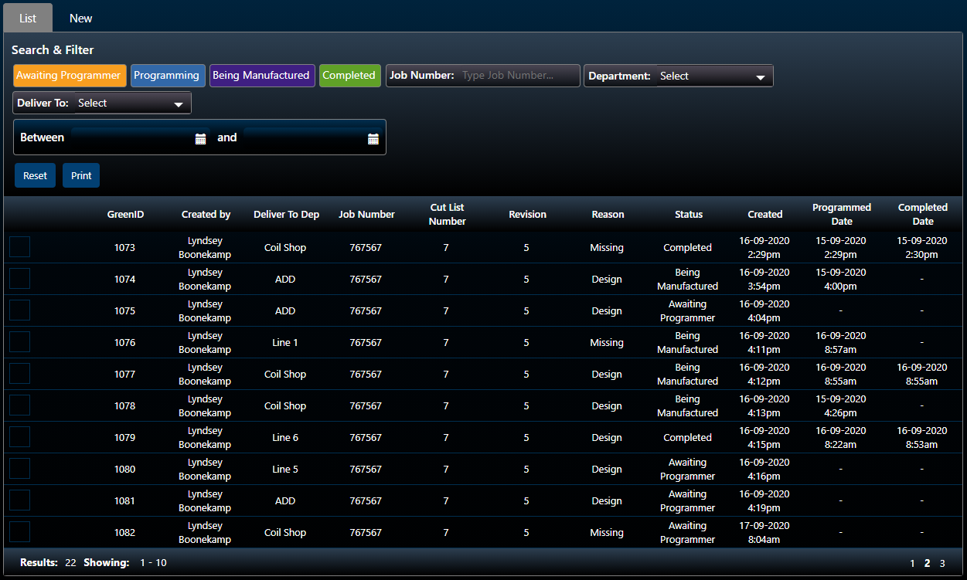

At the top of this window you have all your Search and Filter options.

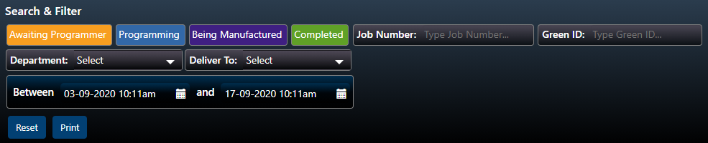

The filters use an ‘and’ approach. Consider the following example.

I want to find items that are still Awaiting Programmer which were raised yesterday and with a Deliver To Department of ADD.

I could perform this search in several ways.

1. I could set the Awaiting Programmer Quick Filter (orange), and not apply any other filters but this might show me too many items.
2. I could select the Awaiting Programmer Quick Filter (orange), use the Date Range filter to set the range to the last day and finally, set the Deliver To field to ADD.

In other words, when you use any of the filters and you’re using more than one, like the example above (2), it’s searching for Greens in a Status of Awaiting Programmer **and** a Date Range of between X and Y **and** a Deliver To Department of ADD.

## Quick Filters

You can use the Quick Filters (coloured) to quickly find Greens in a particular Status.

The Quick Filter will turn black when it’s applied



and show coloured when it’s not applied.



Results are reflected in the table.

## Date Range



To select a Date Range, start by clicking the calendar icon



The Calendar is displayed.

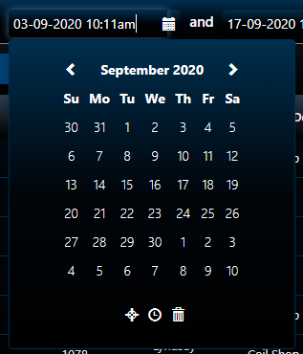

Select a date by clicking any of the calendar days.

To select a Time, select the clock icon at the bottom of the Calendar.



The Time selector is displayed.

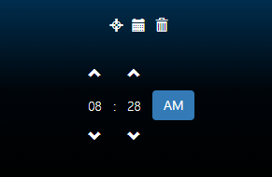

To change either Hours or Minutes, use the arrow icons or type the value in.

To change between AM and PM, use the blue AM | PM button.

Repeat the steps for the ‘and’ field to finish selecting your Date Range.

Results are reflected in the table.

## Job Number or GreenID

To search using the Job Number or GreenID, use the Job Number and Green ID fields.



Type your Job Number or Green ID into the respective field and press the ‘Tab’ or ‘Enter’ key on the keyboard.

Results are reflected in the table.

## Created by Department or Deliver To Department

To search using the Created by Department or Deliver To Department, use the Department and Deliver To fields.



To select a Department for either field, select the field. A dropdown is displayed.

Results are reflected in the table.

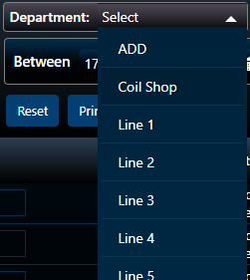

To select a Department, click any of the items.

Results are reflected in the table.

## My results aren’t being returned

If you’re not seeing any results and you’re sure of your search criteria. Try using the ‘Reset’ button to reset the search and then start again. Remember, the ‘and’ approach is used, so if you’re using a combination of filters, be sure these are correct. Alternatively, try using a less specific search criteria.

# Issues/Requests

If you have any issues, please remember to send them directly through to the Temperzone IT helpdesk

Email: [helpdesk@temperzone.com](mailto:helpdesk@temperzone.com) or Phone extension 888 in NZ or AU   
Or visit [helpdesk.temperzone.com](http://helpdesk.temperzone.com/)